Kubernetes Storage

**Practice 1: Direct provisioning of Azure File storage.**



* Setting subscription.

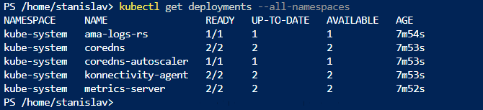

* Checking for running pods.

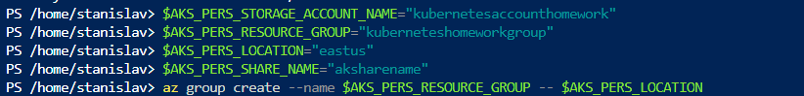

* Setting variables.

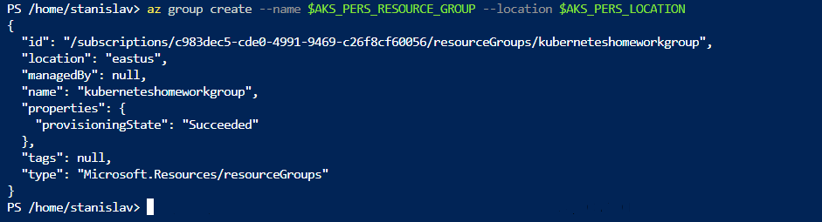

* Creating resource group.

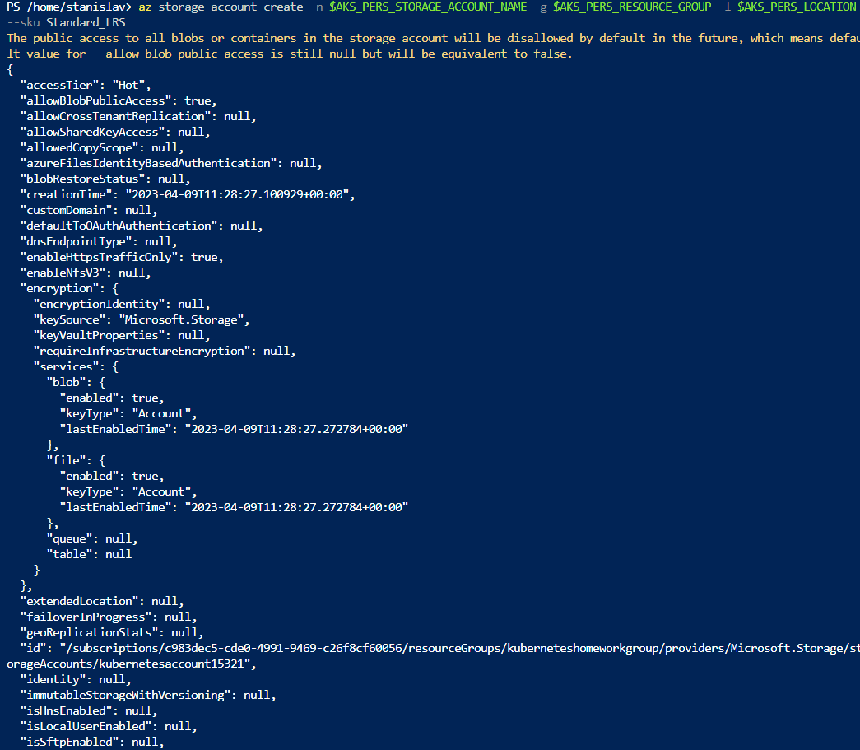

* Creating storage account.



* Exporting the connection string as a variable.



* File share created.



* Getting storage account key.

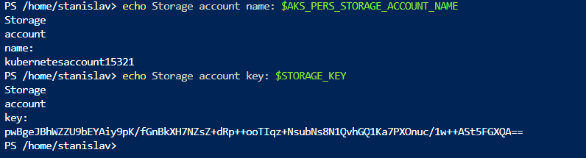

* Storage account name and key.



* Creating a secret.

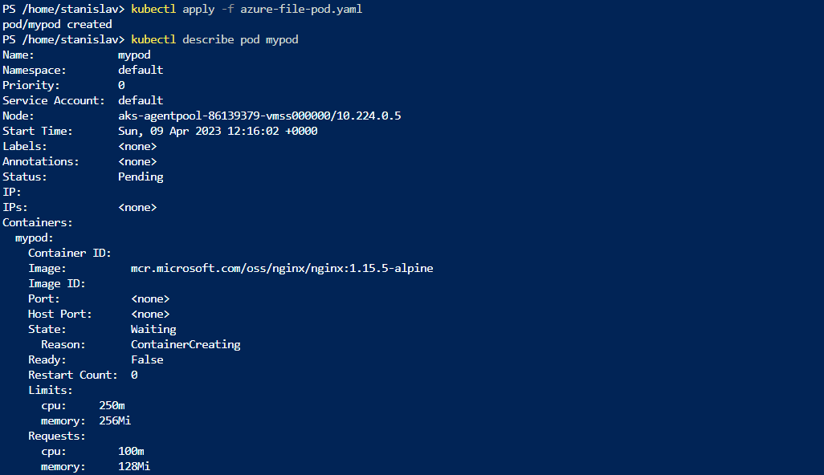

* Creating a pod from a yaml file(every yaml is in my Github).

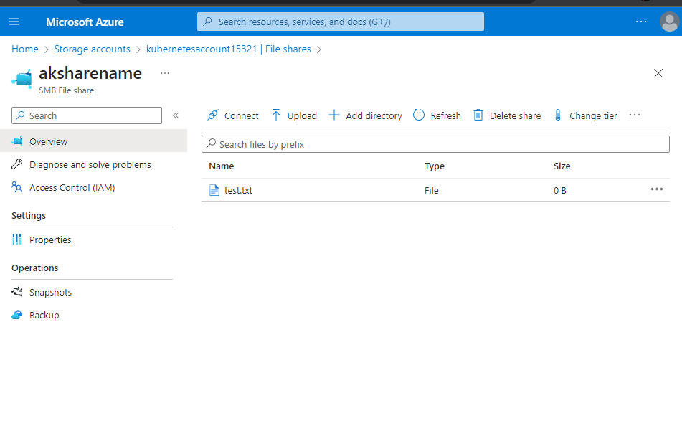

* Checking if the test file is there.

**Practice 2: Provisioning Azure File storage using PVs and PVCs.**



* Deleting the pod, that we created last task.

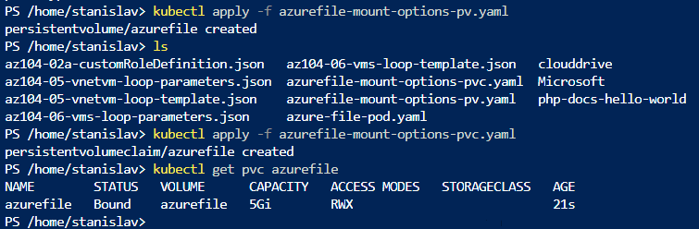

* Executing the two yaml files and verifying the azure file is there.



* Executing the azure-files-pod.

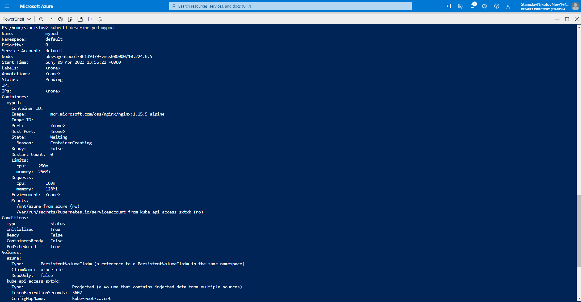

* Output from the kubectl describe

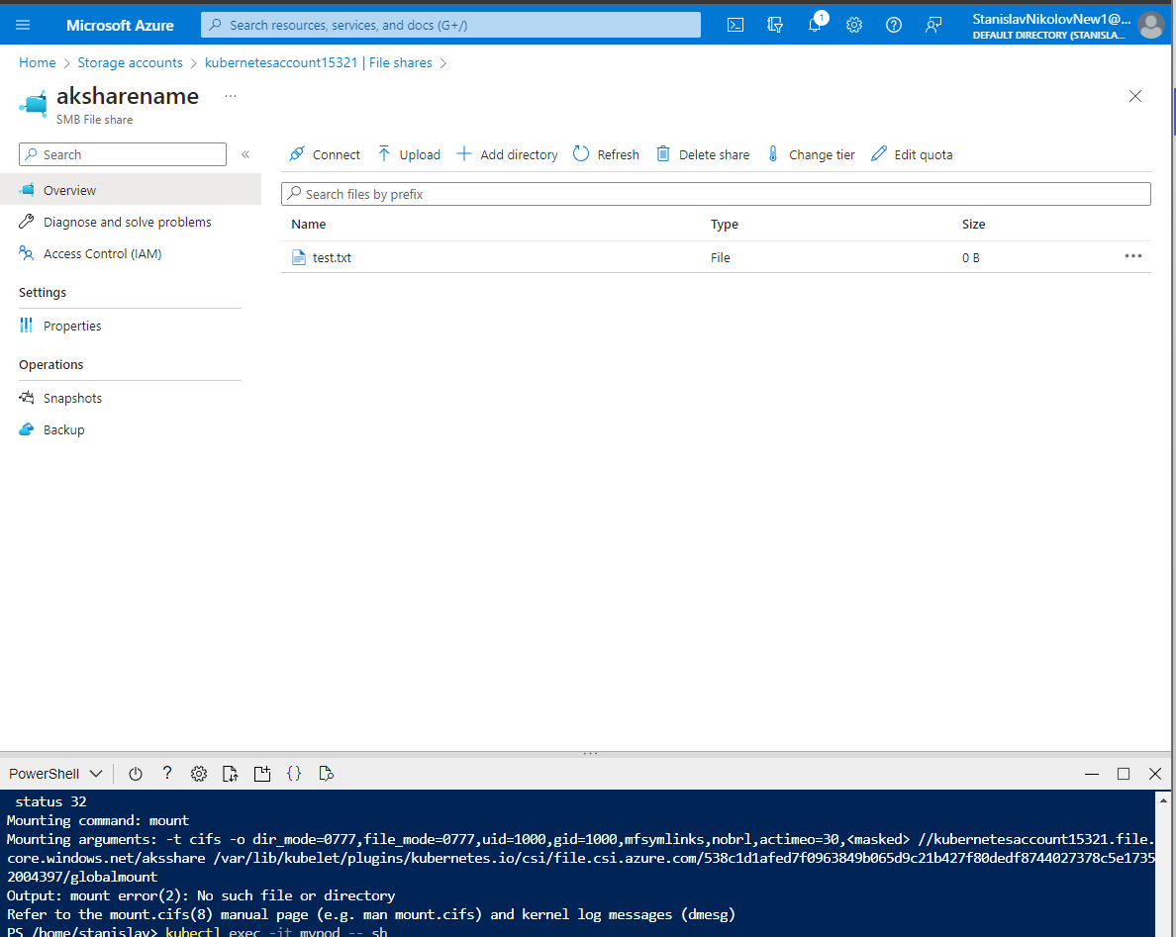

* Checking the files.



* Deleting the azure file.

**Practice 3: Provisioning Azure file storage using Storage Classes.**



* Creating storage class.



* Creating persistent volume.



* Information and credentials.

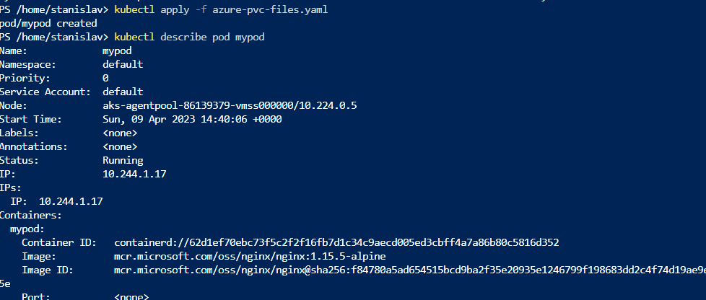

* Creating the pod and some description.

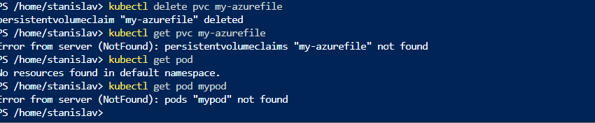

* Deleting the azure-file and the pod.

**Practice 4: Direct provisioning of Azure Disk storage.**



* Creating a disk in the node resource group.



* /subscriptions/c983dec5-cde0-4991-9469-c26f8cf60056/resourceGroups/MC_cluster_ExerciseCluster_westeurope/providers/Microsoft.Compute/disks/myAKSDisk
* Creating the disk resource group.

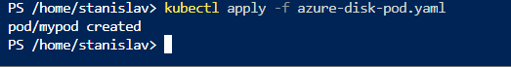

* Creating the disk pod.

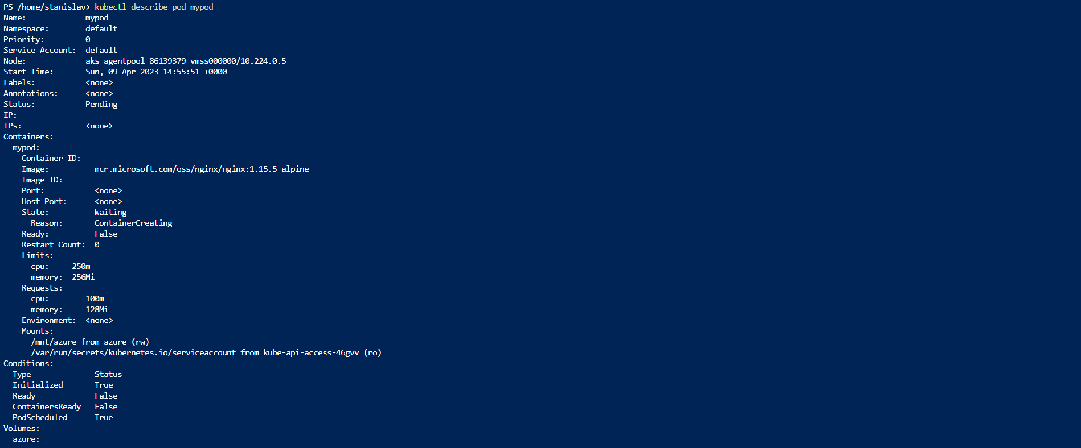

* Description for the pod.



* Deleting mypod.

**Practice 5: Provisioning Azure Disk storage using Storage Classes.**

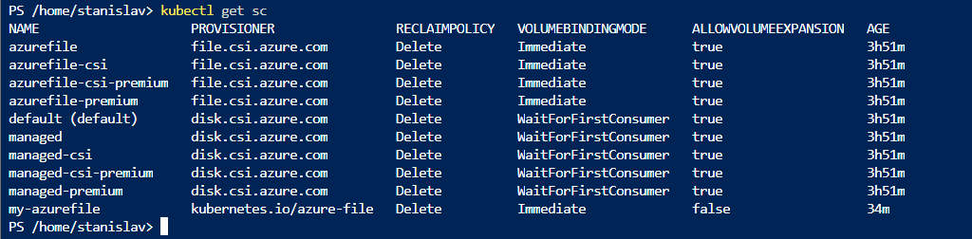

* AKS clusters.

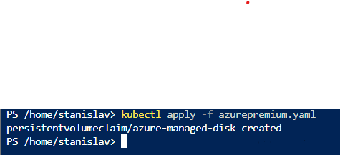

* Persistent volume claim creation.



* Creating the pod.

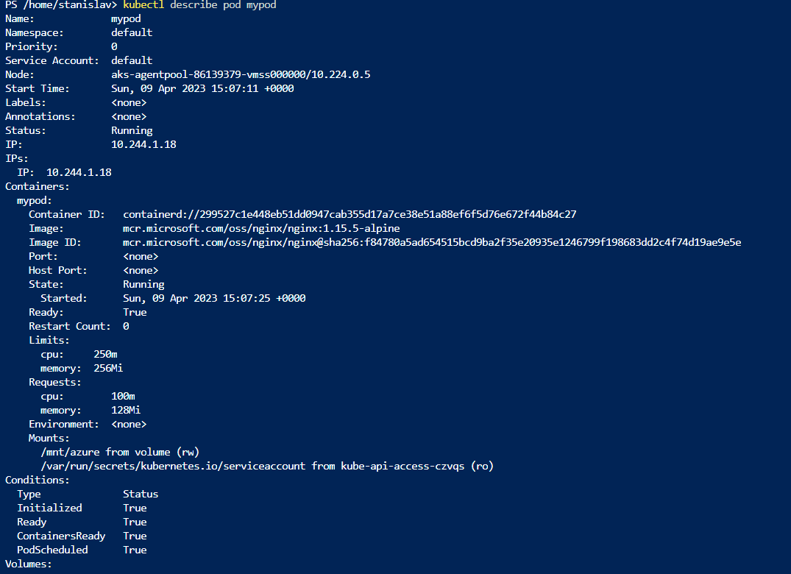

* Describing the created pod.



* Deleting the pod.